SOCIAL STUDIES

WORKSHEET -7

History – 7(THE MAURYAN EMPIRE)

NAME: GRADE: VI
DATE: 21.12.20
I. Answer the following
1. What is an empire?

2. Name the two edicts of emperor Ashoka.

3. What was the saying of the British historian H.G.Wells of emperor Ashoka.

II. Identify and name the picture

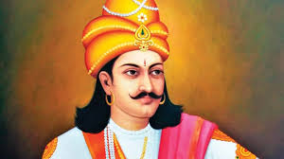
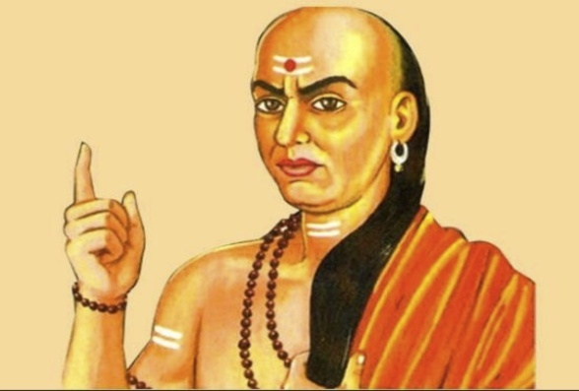

__________________________________ __________________________________
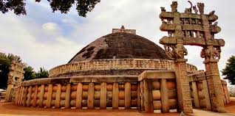
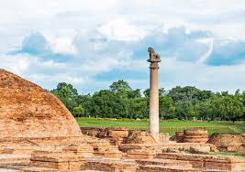

__________________________________ __________________________________

III. Match the Following
1. Indika - Pradeshta
2. Arthashastra - capital
3. Dharma mahamatras - Kautilya
4. Pataliputra - Megasthenese
5.Rajukas - Ashoka officials

